Lab: DOM Introduction
Problems for in-class lab for the "JavaScript Advanced" course @ SoftUni. Submit your solutions in the SoftUni judge system at https://judge.softuni.bg/Contests/2760/DOM-Introduction-Lab
- Edit Element
Create function edit() that takes three parameters.

Input/Output
First parameter is a reference to an HTML element, other two parameters are string – match and replacer.
You have to replace all occurrences of match inside the text content of the given elements with replacer.
- Collect List Items
Write a JS function that scans a given HTML list and appends all collected list items’ text to a text area on the same page when the user clicks on a button.

Input/Output
There will be no input/output, your program should instead modify the DOM of the given HTML document.

Examples
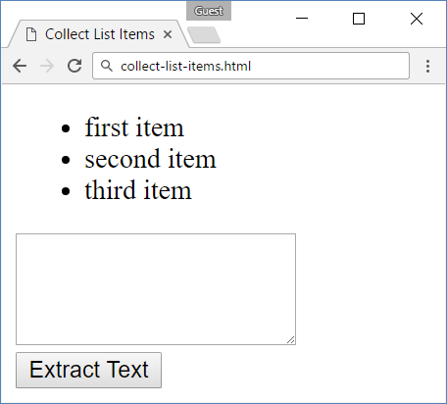 → 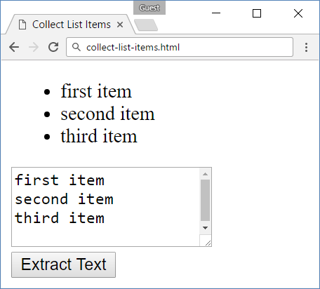

- Sum Numbers
Write a JS function that reads two numbers from input fields in a web page and puts their sum in another field when the user clicks on a button.

Input/Output
There will be no input/output, your program should instead modify the DOM of the given HTML document.

Examples

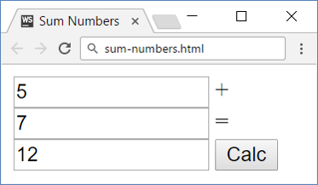
- Show More
Write a JS function that expands a hidden section of text when a link is clicked. The link should disappear as the rest of the text shows up.

Input/Output
There will be no input/output, your program should instead modify the DOM of the given HTML document.

Examples
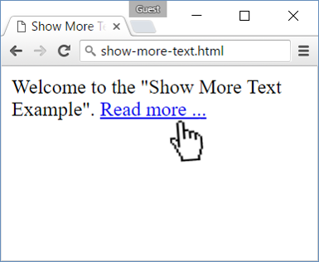 → 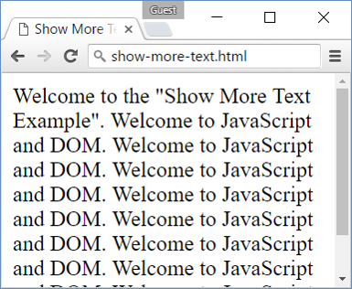
- Colorize Table
Write a JS function that changes the color of all even rows when the user clicks a button. Apply the color "Teal" to the target rows.

Input/Output
There will be no input/output, your program should instead modify the DOM of the given HTML document.

Examples
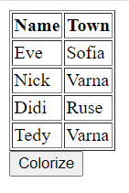 → 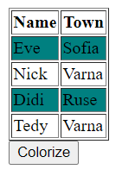
- Sum Table
Write a JS function that finds the first table in a document and sums the values in the last column. The result is then displayed in an element with ID "sum".

Input/Output
There will be no input/output, your program should instead modify the DOM of the given HTML document.

Examples
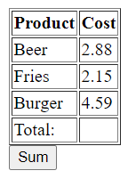→ 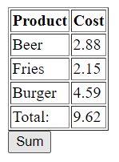

- Extract Parenthesis
Write a JS function that when executed, extracts all parenthesized text from a target paragraph by given element ID. The result is a string, joined by "; " (semicolon, space).

Input
Your function will receive a string parameter, representing the target element ID, from which text must be extracted. The text should be extracted from the DOM.

Output
Return a string with all matched text, separated by "; " (semicolon, space).

Examples
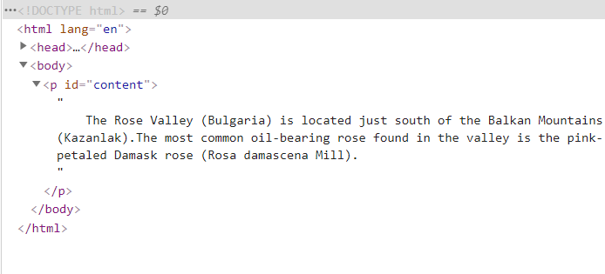
Sample call
let text = extract("content");
Result (stored in variable text)
Bulgaria; Kazanlak; Rosa demascena Mill;

